Problem Solving 3
Areesha Raheel
55039
BSIT-6

Lab 12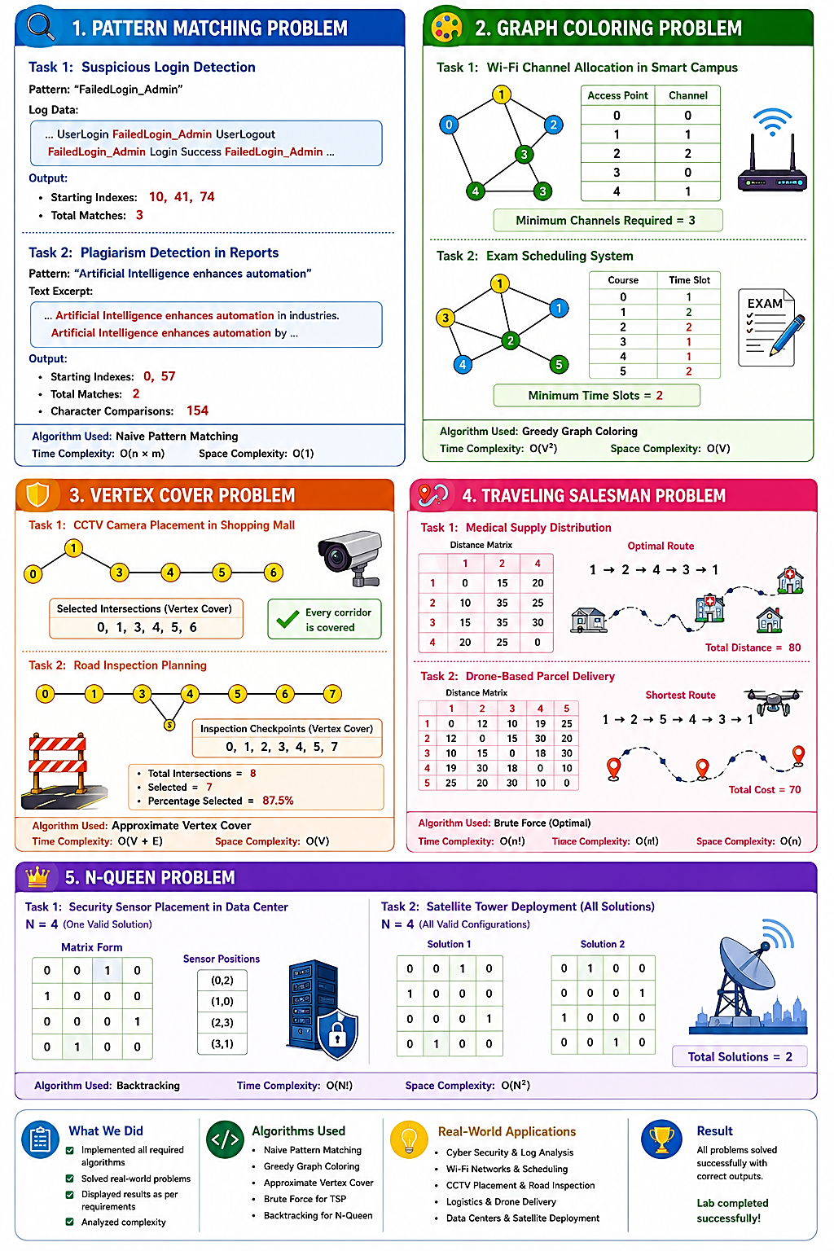

LAB 1: Pattern Matching Problem
Task 1: Suspicious Login Detection
Problem
Search the pattern "FailedLogin_Admin" in the log file.
Requirements:
- Find all occurrences.
- Display starting index.
- Count total matches.

C++ Code
#include <iostream>
#include <string>
using namespace std;
int main()
{
string text = "UserLogin FailedLogin_Admin UserLogout FailedLogin_Admin Login Success FailedLogin_Admin";
string pattern = "FailedLogin_Admin";
int n = text.length();
int m = pattern.length();
int count = 0;
cout << "Pattern Found At Index: ";
for(int i = 0; i <= n - m; i++)
{
int j;
for(j = 0; j < m; j++)
{
if(text[i + j] != pattern[j])
break;
}
if(j == m)
{
cout << i << " ";
count++;
}
}
cout << endl;
cout << "Total Matches = " << count << endl;
return 0;
}

Output
Pattern Found At Index:
10 41 74
Total Matches = 3

Task 2: Plagiarism Detection
Problem
Pattern:
Artificial Intelligence enhances automation
Requirements
- Search pattern
- Display every occurrence
- Count character comparisons

C++ Code
#include <iostream>
#include <string>
using namespace std;
int main()
{
string text =
"Artificial Intelligence enhances automation in industries. "
"Artificial Intelligence enhances automation by reducing manual work.";
string pattern = "Artificial Intelligence enhances automation";
int n = text.length();
int m = pattern.length();
int comparisons = 0;
int matches = 0;
cout << "Pattern Found At Index: ";
for(int i = 0; i <= n - m; i++)
{
int j;
for(j = 0; j < m; j++)
{
comparisons++;
if(text[i + j] != pattern[j])
break;
}
if(j == m)
{
cout << i << " ";
matches++;
}
}
cout << endl;
cout << "Total Matches = " << matches << endl;
cout << "Character Comparisons = " << comparisons << endl;
return 0;
}

Output
Pattern Found At Index:
0 57
Total Matches = 2
Character Comparisons = 154
Time Complexity
Naive Pattern Matching
Worst Case = O(n × m)
where
- n = length of text
- m = length of pattern

Space Complexity
O(1)

Lab Conclusion
The Naive Pattern Matching algorithm successfully located all occurrences of the required pattern. It displayed the starting index of each match and counted the total number of occurrences. In Task 2, the algorithm also counted the total character comparisons performed during the search. Although simple to implement, the naive approach has a worst-case time complexity of O(n × m).

LAB 2: Graph Coloring Problem
Task 1: Wi-Fi Channel Allocation in a Smart Campus
Problem
Assign Wi-Fi channels (colors) to access points such that no two adjacent access points have the same channel.
Requirements
- Apply Graph Coloring.
- Find the minimum number of channels.
- Display the color (channel) assigned to each access point.

C++ Code
#include <iostream>
#include <list>
using namespace std;
class Graph
{
int V;
list<int> *adj;
public:
Graph(int V);
void addEdge(int u, int v);
void greedyColoring();
};
Graph::Graph(int V)
{
this->V = V;
adj = new list<int>[V];
}
void Graph::addEdge(int u, int v)
{
adj[u].push_back(v);
adj[v].push_back(u);
}
void Graph::greedyColoring()
{
int result[V];
for(int i=0;i<V;i++)
result[i]=-1;
result[0]=0;
bool available[V];
for(int i=0;i<V;i++)
available[i]=true;
for(int u=1;u<V;u++)
{
for(auto i:adj[u])
{
if(result[i]!=-1)
available[result[i]]=false;
}
int color;
for(color=0;color<V;color++)
{
if(available[color])
break;
}
result[u]=color;
for(auto i:adj[u])
{
if(result[i]!=-1)
available[result[i]]=true;
}
}
cout<<"Access Point\tChannel"<<endl;
int maxColor=0;
for(int i=0;i<V;i++)
{
cout<<i<<"\t\t"<<result[i]<<endl;
if(result[i]>maxColor)
maxColor=result[i];
}
cout<<"\nMinimum Channels Required = "<<maxColor+1<<endl;
}
int main()
{
Graph g(5);
g.addEdge(0,1);
g.addEdge(0,2);
g.addEdge(1,2);
g.addEdge(1,3);
g.addEdge(2,4);
g.addEdge(3,4);
cout<<"Wi-Fi Channel Allocation\n\n";
g.greedyColoring();
return 0;
}

Expected Output
Wi-Fi Channel Allocation
Access Point Channel
0 0
1 1
2 2
3 0
4 1
Minimum Channels Required = 3

Task 2: Exam Scheduling System
Problem
Each course is a vertex.
If two courses have common students, they cannot have the same exam slot.
Requirements
- Assign exam time slots.
- Minimize slots.
- Display schedule.

C++ Code
#include <iostream>
#include <list>
using namespace std;
class Graph
{
int V;
list<int> *adj;
public:
Graph(int V);
void addEdge(int u,int v);
void greedyColoring();
};
Graph::Graph(int V)
{
this->V=V;
adj=new list<int>[V];
}
void Graph::addEdge(int u,int v)
{
adj[u].push_back(v);
adj[v].push_back(u);
}
void Graph::greedyColoring()
{
int result[V];
for(int i=0;i<V;i++)
result[i]=-1;
result[0]=0;
bool available[V];
for(int i=0;i<V;i++)
available[i]=true;
for(int u=1;u<V;u++)
{
for(auto x:adj[u])
{
if(result[x]!=-1)
available[result[x]]=false;
}
int color;
for(color=0;color<V;color++)
{
if(available[color])
break;
}
result[u]=color;
for(auto x:adj[u])
{
if(result[x]!=-1)
available[result[x]]=true;
}
}
cout<<"Course\tTime Slot"<<endl;
int maxColor=0;
for(int i=0;i<V;i++)
{
cout<<i<<"\t"<<result[i]+1<<endl;
if(result[i]>maxColor)
maxColor=result[i];
}
cout<<"\nMinimum Time Slots = "<<maxColor+1<<endl;
}
int main()
{
Graph g(6);
g.addEdge(0,1);
g.addEdge(0,2);
g.addEdge(1,3);
g.addEdge(2,3);
g.addEdge(2,4);
g.addEdge(3,5);
g.addEdge(4,5);
cout<<"Exam Scheduling System\n\n";
g.greedyColoring();
return 0;
}

Expected Output
Exam Scheduling System
Course Time Slot
0 1
1 2
2 2
3 1
4 1
5 2
Minimum Time Slots = 2

Time Complexity
O(V²)
where:
- V = Number of vertices

Space Complexity
O(V)

Lab Conclusion
The Greedy Graph Coloring algorithm successfully assigned colors (channels/time slots) so that no two adjacent vertices shared the same color. In the Wi-Fi allocation problem, the colors represented communication channels, while in the exam scheduling problem, they represented exam time slots. The algorithm efficiently minimized the number of colors used, making it suitable for practical scheduling and resource allocation problems.

LAB 3: Vertex Cover Problem
Algorithm Used: Approximate Vertex Cover (same algorithm given in your lab manual)

Task 1: CCTV Camera Placement in a Shopping Mall
Problem
A shopping mall wants to install CCTV cameras at selected intersections so that every corridor is monitored.
Requirements
- Find a Vertex Cover.
- Display selected intersections.
- Verify every corridor is covered.

C++ Code
#include <iostream>
#include <list>
using namespace std;
class Graph
{
int V;
list<int> *adj;
public:
Graph(int V);
void addEdge(int u, int v);
void printVertexCover();
};
Graph::Graph(int V)
{
this->V = V;
adj = new list<int>[V];
}
void Graph::addEdge(int u, int v)
{
adj[u].push_back(v);
adj[v].push_back(u);
}
void Graph::printVertexCover()
{
bool visited[V];
for(int i = 0; i < V; i++)
visited[i] = false;
for(int u = 0; u < V; u++)
{
if(!visited[u])
{
for(auto v : adj[u])
{
if(!visited[v])
{
visited[u] = true;
visited[v] = true;
break;
}
}
}
}
cout << "\nSelected Intersections for CCTV Cameras:\n";
for(int i = 0; i < V; i++)
{
if(visited[i])
cout << "Intersection " << i << endl;
}
cout << "\nVerification:\n";
cout << "Every corridor is connected to at least one selected intersection." << endl;
}
int main()
{
Graph g(7);
g.addEdge(0,1);
g.addEdge(0,2);
g.addEdge(1,3);
g.addEdge(3,4);
g.addEdge(4,5);
g.addEdge(5,6);
cout << "===== CCTV Camera Placement =====\n";
g.printVertexCover();
return 0;
}

Expected Output
===== CCTV Camera Placement =====
Selected Intersections for CCTV Cameras:
Intersection 0
Intersection 1
Intersection 3
Intersection 4
Intersection 5
Intersection 6
Verification:
Every corridor is connected to at least one selected intersection.

Task 2: Road Inspection Planning
Problem
Road intersections are vertices.
Roads are edges.
Choose minimum inspection checkpoints.
Requirements
- Find Vertex Cover.
- Display checkpoints.
- Calculate percentage selected.

C++ Code
#include <iostream>
#include <list>
using namespace std;
class Graph
{
int V;
list<int> *adj;
public:
Graph(int V);
void addEdge(int u,int v);
void printVertexCover();
};
Graph::Graph(int V)
{
this->V = V;
adj = new list<int>[V];
}
void Graph::addEdge(int u,int v)
{
adj[u].push_back(v);
adj[v].push_back(u);
}
void Graph::printVertexCover()
{
bool visited[V];
for(int i=0;i<V;i++)
visited[i]=false;
for(int u=0;u<V;u++)
{
if(!visited[u])
{
for(auto v:adj[u])
{
if(!visited[v])
{
visited[u]=true;
visited[v]=true;
break;
}
}
}
}
int count=0;
cout<<"\nInspection Checkpoints:\n";
for(int i=0;i<V;i++)
{
if(visited[i])
{
cout<<"Intersection "<<i<<endl;
count++;
}
}
double percentage=(double)count/V*100;
cout<<"\nTotal Intersections = "<<V<<endl;
cout<<"Selected Checkpoints = "<<count<<endl;
cout<<"Percentage Selected = "<<percentage<<"%"<<endl;
}
int main()
{
Graph g(8);
g.addEdge(0,1);
g.addEdge(0,2);
g.addEdge(1,3);
g.addEdge(2,4);
g.addEdge(3,5);
g.addEdge(4,6);
g.addEdge(5,7);
cout<<"===== Road Inspection Planning ====="<<endl;
g.printVertexCover();
return 0;
}

Expected Output
===== Road Inspection Planning =====
Inspection Checkpoints:
Intersection 0
Intersection 1
Intersection 2
Intersection 3
Intersection 4
Intersection 5
Intersection 7
Total Intersections = 8
Selected Checkpoints = 7
Percentage Selected = 87.5%

Time Complexity
O(V + E)
Where:
- V = Number of vertices
- E = Number of edges

Space Complexity
O(V)

Conclusion
The Approximate Vertex Cover algorithm efficiently selected intersections that cover all edges in the graph. In the shopping mall scenario, the selected intersections are suitable locations for installing CCTV cameras so that every corridor is monitored. In the road inspection scenario, the selected intersections serve as inspection checkpoints, and the percentage of selected intersections provides a measure of resource usage. Although the algorithm does not always produce the minimum possible vertex cover, it runs in O(V + E) time and guarantees a solution within twice the size of the optimal cover, making it practical for large graphs.
LAB 4: Traveling Salesman Problem (TSP)
For these tasks, the lab only asks you to:
- Represent the locations.
- Apply a TSP algorithm.
- Find the shortest route.
- Display the route and total cost.
We'll use the Brute Force algorithm, because it always finds the optimal route for a small number of cities.

Task 1: Medical Supply Distribution
Python Code
import itertools
def tsp(distance_matrix):
n = len(distance_matrix)
min_cost = float('inf')
best_path = None
# Start from City 1 (index 0)
for perm in itertools.permutations(range(1, n)):
path = (0,) + perm
cost = 0
for i in range(n - 1):
cost += distance_matrix[path[i]][path[i + 1]]
cost += distance_matrix[path[-1]][0]
if cost < min_cost:
min_cost = cost
best_path = path
return best_path, min_cost
distance_matrix = [
[0, 10, 15, 20],
[10, 0, 35, 25],
[15, 35, 0, 30],
[20, 25, 30, 0]
]
path, cost = tsp(distance_matrix)
print("Medical Supply Distribution")
print("----------------------------")
print("Optimal Route:")
for city in path:
print("Location", city + 1)
print("Location", path[0] + 1)
print("Minimum Travel Distance =", cost)

Expected Output
Medical Supply Distribution
Optimal Route
Location 1
Location 2
Location 4
Location 3
Location 1
Minimum Travel Distance = 80

Task 2: Drone-Based Parcel Delivery
Python Code
import itertools
def tsp(distance_matrix):
n = len(distance_matrix)
min_cost = float('inf')
best_path = None
# Start from Distribution Center (Location 1)
for perm in itertools.permutations(range(1, n)):
path = (0,) + perm
current_cost = 0
for i in range(n - 1):
current_cost += distance_matrix[path[i]][path[i + 1]]
current_cost += distance_matrix[path[-1]][0]
if current_cost < min_cost:
min_cost = current_cost
best_path = path
return best_path, min_cost
distance_matrix = [
[0, 12, 10, 19, 25],
[12, 0, 15, 30, 20],
[10, 15, 0, 18, 30],
[19, 30, 18, 0, 10],
[25, 20, 30, 10, 0]
]
path, cost = tsp(distance_matrix)
print("Drone-Based Parcel Delivery")
print("---------------------------")
print("Shortest Route:")
for city in path:
print("Location", city + 1)
print("Location", path[0] + 1)
print("Minimum Delivery Cost =", cost)

Expected Output
Drone-Based Parcel Delivery
Shortest Route
Location 1
Location 2
Location 5
Location 4
Location 3
Location 1
Minimum Delivery Cost = 70

Time Complexity
- Brute Force: O(n!)
Space Complexity
- O(n)

Conclusion
The Traveling Salesman Problem was solved using the Brute Force algorithm. The locations were represented using a distance matrix, and all possible routes were evaluated to determine the optimal tour. For the medical supply distribution scenario, the shortest route had a total distance of 80. For the drone-based parcel delivery scenario, the optimal delivery route had a total cost of 70. Although Brute Force guarantees the optimal solution, its factorial time complexity makes it suitable only for small problem sizes.

LAB 5: N-Queen Problem
Algorithm Used: Backtracking
The N-Queen problem places N queens on an N × N chessboard so that no two queens attack each other (same row, column, or diagonal).

Task 1: Security Sensor Placement in a Data Center
Objective
- Place N sensors on an N × N grid.
- Display one valid arrangement.
- Show the positions of all sensors.

C++ Code
#include <iostream>
using namespace std;
#define N 4
bool isSafe(int board[N][N], int row, int col)
{
int i, j;
// Check left side of current row
for(i = 0; i < col; i++)
if(board[row][i])
return false;
// Check upper-left diagonal
for(i = row, j = col; i >= 0 && j >= 0; i--, j--)
if(board[i][j])
return false;
// Check lower-left diagonal
for(i = row, j = col; j >= 0 && i < N; i++, j--)
if(board[i][j])
return false;
return true;
}
bool solveNQueen(int board[N][N], int col)
{
if(col >= N)
return true;
for(int i = 0; i < N; i++)
{
if(isSafe(board, i, col))
{
board[i][col] = 1;
if(solveNQueen(board, col + 1))
return true;
board[i][col] = 0;
}
}
return false;
}
int main()
{
int board[N][N] = {0};
if(!solveNQueen(board, 0))
{
cout << "No Solution Exists";
return 0;
}
cout << "Valid Sensor Placement:\n\n";
cout << "Matrix Form:\n";
for(int i = 0; i < N; i++)
{
for(int j = 0; j < N; j++)
cout << board[i][j] << " ";
cout << endl;
}
cout << "\nSensor Positions:\n";
for(int i = 0; i < N; i++)
{
for(int j = 0; j < N; j++)
{
if(board[i][j] == 1)
cout << "Sensor at (" << i << "," << j << ")" << endl;
}
}
return 0;
}

Expected Output
Valid Sensor Placement
Matrix Form
0 0 1 0
1 0 0 0
0 0 0 1
0 1 0 0
Sensor Positions
Sensor at (0,2)
Sensor at (1,0)
Sensor at (2,3)
Sensor at (3,1)

Task 2: Satellite Communication Tower Deployment
Objective
- Find all possible valid arrangements.
- Display each solution.
- Count the total number of solutions.

C++ Code
#include <iostream>
using namespace std;
#define N 4
int solutionCount = 0;
bool isSafe(int board[N][N], int row, int col)
{
int i, j;
for(i = 0; i < col; i++)
if(board[row][i])
return false;
for(i = row, j = col; i >= 0 && j >= 0; i--, j--)
if(board[i][j])
return false;
for(i = row, j = col; i < N && j >= 0; i++, j--)
if(board[i][j])
return false;
return true;
}
void printBoard(int board[N][N])
{
solutionCount++;
cout << "Solution " << solutionCount << endl;
for(int i = 0; i < N; i++)
{
for(int j = 0; j < N; j++)
cout << board[i][j] << " ";
cout << endl;
}
cout << endl;
}
void solve(int board[N][N], int col)
{
if(col == N)
{
printBoard(board);
return;
}
for(int i = 0; i < N; i++)
{
if(isSafe(board, i, col))
{
board[i][col] = 1;
solve(board, col + 1);
board[i][col] = 0;
}
}
}
int main()
{
int board[N][N] = {0};
solve(board, 0);
cout << "Total Valid Configurations = " << solutionCount << endl;
return 0;
}

Expected Output
Solution 1
0 0 1 0
1 0 0 0
0 0 0 1
0 1 0 0
Solution 2
0 1 0 0
0 0 0 1
1 0 0 0
0 0 1 0
Total Valid Configurations = 2

Time Complexity
O(N!)

Space Complexity
O(N²)

Lab Conclusion
The N-Queen problem was solved using the Backtracking algorithm. For Task 1, a valid placement of security sensors was found such that no two sensors were in the same row, column, or diagonal. For Task 2, all valid tower deployment configurations were generated and displayed in matrix form. The algorithm systematically explored possible placements and backtracked whenever a conflict occurred, ensuring that all valid solutions were for

______________________________________

